**CHAPTER I**

**INTRODUCTION**

Electricity is the only form of energy which is easy to produce, easy to transport, easy to use, and easy to control. So, it is mostly the terminal form of energy for transmission and distribution. Electricity consumption per capita is the index of the living standard of people of a place or country. Also, it is an extremely versatile form of energy. It can be generated in many ways and from many different sources. It can be sent almost instantaneously over long distances. Electricity can also be converted efficiently into other forms of energy, and it can be stored. Because of this versatility, electricity plays a part in nearly every aspect of modern technology. Electricity provides light, heat, and mechanical power. It makes cell phones, computers, televisions, and countless other necessities and luxuries possible.

The Department of Energy (DOE) forecasts a total System Peak Demand of 12,285 MegaWatts (MW) for Luzon to occur in May 2020, an increase of 8.3% from the actual 2019 peak demand of 11,344MW which occurred on 21 June 2019.

According to NGCP, “There appears to be a shift in the way consumers uses power. Luzon’s annual peak demand was long driven by increased use during the hot summer months. Mindanao and Visayas peak usage usually occur at the end of the year. The Regulator and authorities must take a closer look at the shifts in peak demand and strategize short term and long-term solutions to address the ever-increasing need for power vis-à-vis power consumption trends,”.

Thin electricity supply is forecasted between April to June 2020, even with an expected incoming 700MW capacity from new power plants. The Luzon grid needs around 4% of the peak demand, or around 491MW in regulating power to stabilize the grid; it also needs to maintain power equivalent to the largest plant online (usually equivalent to 647MW) as contingency power to support the grid in case of an emergency power plant shutdown.

“With the increase in power demand, lack of new baseload plants, power plants de-commissioning and longer unplanned maintenance shutdowns of aging plants, as well as the unpredictable weather, NGCP is urging the authorities to focus efforts on stemming what seems to be an impending power shortage in Luzon, especially during the summer season. As the Transmission Network Provider and System Operator, NGCP performs its functions within the bounds of its mandate. We cannot provide or implement solutions to a generation deficiency-induced shortage,” NGCP appealed.

A steam power plant continuously converts the energy stored in the fossil fuels (coal, oil, natural gas) or fissile fuels (uranium, thorium) into shaft work and ultimately into electricity. The working fluid is water which is sometimes in the vapor phase during its cycle of operations. Energy released by the burning of fuel is transferred to water in the boiler to generate steam at a high pressure and temperature, which then expands in the turbine to a low pressure to produce shaft work. The steam leaving the turbine is condensed into water in the condenser where cooling water from a river or sea circulates carrying away the heat released during condensation. The water (condensate) is then fed back to the boiler by the pump, and the cycle goes on repeating itself.

Moreover, electricity is very much needed not only for household purposes but for industries, offices, and for recreational purposes as well. Therefore, the power supplier needs not only to deliver the power, but most important of all, is the availability of such power supply at any given time interval. This is a sure profit business.

In line with the article reported, it was determined that building a new power plant on the Luzon grid will be beneficial and profitable. The purpose of this study is to design a steam power plant that will produce a power of 500 MW in order to cater the needed demand of electricity in the region.

**The Subject of the Report**

This project study focuses mainly on the design of a **500** MW Coal-Fired Power Plant located at Brgy. Lumaniag, Lian, Batangas. This research includes the basic foundations and essential factors regarding the location of the plant as well as the design of the layout of the plant considering the codes and standards for Engineering, environmental and economic effects, health and safety issues, etc. The research involves critical operational conditioned-based criteria. The current plant profiles are evaluated as the reference data in order to establish the plant layout and location. The research will also include the financial evaluation for the design project cost overview, cost calculation and complete cost calculation of the power plant. The observation, conclusion and recommendation will also be included.

**Capitalization**

Adequate financing is considered for the establishment and activity of the plant. To make sure about the plant's financing may originate from the plant's proprietor, and public funding. Fifty percent of the financing gave will originate from the proprietor or administrator of the plant, thirty percent of the absolute cost will be held through public funding and the remaining twenty percent will originate from bank loans.

**Ownership**

The owner of the proposed coal-fired power plant according to the fulfillment of the venture will be the AHHMS Power Generation Corporation. This organization is a coal-fired power plant and will utilize sub-bituminous coal as the essential fuel. The association in the organization will be the person who has the power and position to choose where the recommended coal-fired vitality plant will be found. All utilities, infrastructure and facility equipment have a place with the said organization.

**Organizational Set-up with Technical Organization**

This is the AHHMS Power Generation Corporation technical organization.

**Figure 1.** Organizational Chart

Figure 1 shows the structure of an organization and the relationships and relative ranks of its positions or jobs.

**Location Map**

For the location of the proposed design of coal-powered power plant, three municipalities in Batangas were considered: Calatagan, Lian and Nasugbu. Each chosen areas are located near bodies of water which are important as a source for plant operations. The location in Calatagan however, seemed to conflict with the type of land the municipality has since nowadays, people require more agricultural crops to supplement the increasing demand of the country. This narrows the options to Lian and Nasugbu. For both options, Nasugbu seemed to conflict with the neighboring commercial resorts as it would affect their business and the type of land the municipality has. Therefore, it was concluded that the location in Lian is the most applicable option among the three. Even if the location in Lian needs additional labor to flatten the land which is elevated by 70 m, it is chosen since it has a commercial type of land and can also be easily reached in road transportation. Several parameters were also considered in comparing the three possible locations.

**Table 1**

**Comparison of Parameters of the Three Locations**

|  |  |  |  |
| --- | --- | --- | --- |
| **Parameters** | **Location 1**  **Calatagan** | **Location 2**  **Lian** | **Location 3**  **Nasugbu** |
| Surrounding bodies of water | Present | Present | Present |
| Topography | Elevated | Elevated | Flat |
| Nearness of the load center | Near | Near | Near |
| Road Transportation | Easy | Easy | Easy |
| Type of land | Agricultural | Commercial | Agricultural |
| Disturbances | Many resorts | Forestation | Many resorts |

Table 1 shows the different parameters used to determine the plant location. All of the locations are strategically located near bodies of water. The location in Calatagan is located along the coast of Pagaspas Bay and the location in Lian and Nasugbu are both located along Nasugbu Bay. All of the locations are open areas for the construction of large facilities.

The researchers decided to install the proposed power plant in Brgy. Lumaniag, Lian, Batangas due to its strategic location with regards to the availability of sources of water, nearness to the load center, road transportation, type of land and fuel transport via sea. The chosen location will provide electricity to the different municipalities in the province of Batangas.

Lian, officially the Municipality of Lian, is a 3rd class municipality in the province of Batangas, Philippines. It is also a coastal municipality of the province. According to the 2015 census, it has a population of 52,660 people. The municipality is located in the northwestern part of Batangas Province and bounded on the north by the Municipality of Nasugbu; on the east by the Municipalities of Tuy and Balayan, on the west by South China Sea and on the south by the Municipality of Calatagan.  It is geographically situated at 120 degrees 39’ longitude and 14 degrees 12’ latitude. The municipality has a land area of 76.80 square kilometers which constitutes 2.46% of Batangas’ total area. It is also located between BATELEC I in Calatagan and BATELEC I Substation in Nasugbu.

Brgy. Lumaniag is located along the coast of Nasugbu Bay. In 2015 census, its population was determined as 2,309 which constitutes 4.38% of the total population of Lian. The specific location of the power plant is at 14°00”42’ North and 120°37”07’ East of the Philippines.

Below is the proposed plant location located at Brgy. Lumaniag, Lian, Batangas.

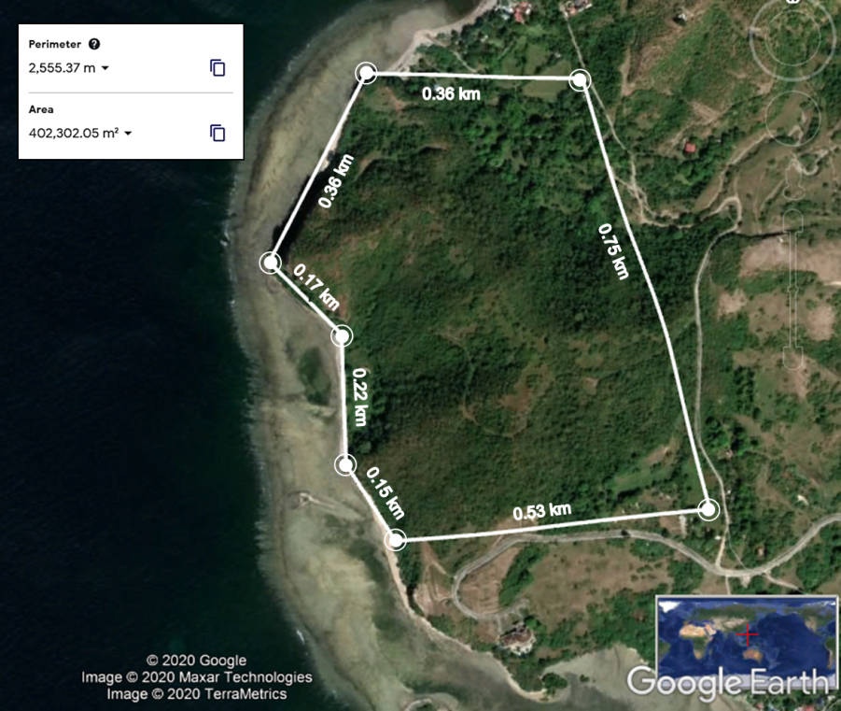

**Figure 2.** Proposed Location of the Coal-Fired Power Plant (Google Earth, 2020)

Figure 2 shows the location of the proposed plant site. The proposed coal-fired power plant is to be located in Brgy. Lumaniag, Lian, Batangas.

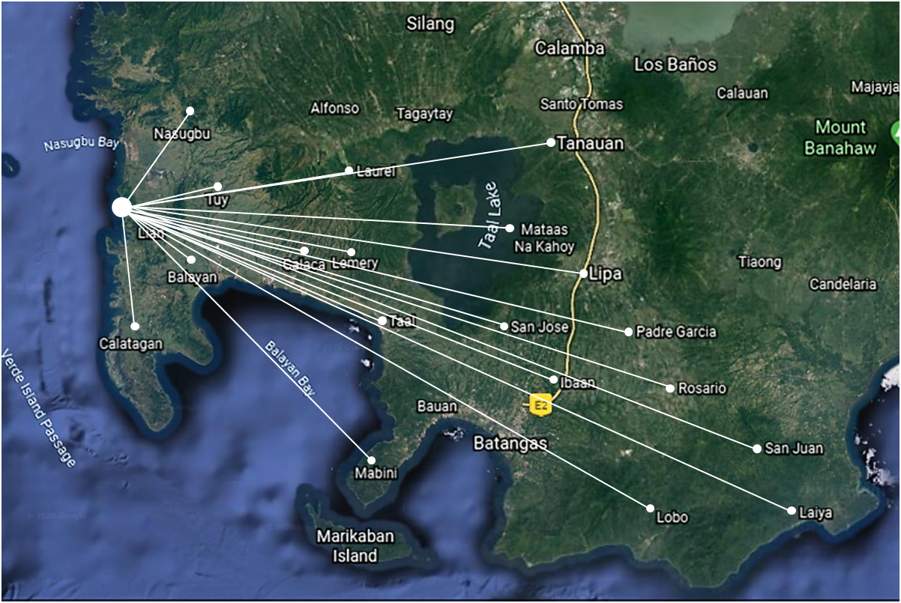

**Figure 3.** Plant location showing the target municipalities in the province of Batangas (Google Earth, 2020)

Figure 3 shows the target municipalities to be supplied by the proposed coal-fired power plant in Lian, Batangas. Its primary purpose is to provide energy for the province of Batangas with the help of the distribution units of BATELEC I, BATELEC II, First Bay Power Corporation (FBPC) and Ibaan Electric Engineering Corporation (IEEC). BATELEC I distributes electricity in the municipalities of Nasugbu, Lian, Calatagan, Balayan, Tuy, Lemery, Calaca, Agoncillo, San Nicolas, Sta. Teresita and San Luis. BATELEC II distributes electricity to the municipalities of Laurel, Talisay, Tanauan, Malvar, Balete, Lipa, Cuenca, San Jose, Alitagtag, Mabini, Tingloy, Padre Garcia, Rosario, Lobo, San Juan and Taysan. The additional power produced can be distributed also in some areas in Manila that are connected to the Luzon Grid such as MERALCO. Some articles has shown that Luzon grid is in need of around 491 MW in order to stabilize the grid and maintain power to support the grid.

**Load Projection**